**Chapter 5**

**Integration**

**5.1. Approximating Areas**

**Section Exercises**

1. State whether the given sums are equal or unequal.

1.  and 
2.  and 
3.  and 
4.  and 

Answer: a. They are equal; both represent the sum of the first 10 whole numbers. b. They are equal; both represent the sum of the first 10 whole numbers. c. They are equal by substituting . d. They are equal; the first sum factors the terms of the second.

**In the following exercises, use the rules for sums of powers of integers to compute the sums.**

3. 

Answer: 

Suppose that  and . In the following exercises, compute the sums.

5. 

Answer: 

7. 

Answer: 

**In the following exercises, use summation properties and formulas to rewrite and evaluate the sums.**

9. 

Answer: 

11. 

Answer: 

**Let  denote the left-endpoint sum using *n* subintervals and let  denote the corresponding right-endpoint sum. In the following exercises, compute the indicated left and right sums for the given functions on the indicated interval.**

13. *R*4 for  on 

Answer: 

15. *R*6 for  on 

Answer: 

17. *L*4 for  on 

Answer: 

19. *L*8 for  on 

Answer: 

21. Compute the left and right Riemann sums—*L*6 and *R*6, respectively—for  on . Compute their average value and compare it with the area under the graph of *f*.

Answer: . The graph of *f* is a triangle with area 9.

23. Compute the left and right Riemann sums—*L*6 and *R*6, respectively—for  on  and compare their values.

Answer: . They are equal.

**Express the following endpoint sums in sigma notation but do not evaluate them.**

25. *L*10 for  on 

Answer: 

27. *R*100 for  on 

Answer: 

**In the following exercises, graph the function then use a calculator or a computer program to evaluate the following left and right endpoint sums. Is the area under the curve between the left and right endpoint sums?**

29. **[T]** *L*100 and *R*100 for on the interval 

Answer:

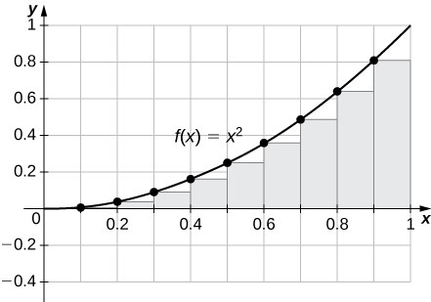

, . The plot shows that the left Riemann sum is an underestimate because the function is increasing. Similarly, the right Riemann sum is an overestimate. The area lies between the left and right Riemann sums. Ten rectangles are shown for visual clarity. This behavior persists for more rectangles.

31. **[T]** *L*100 and *R*100 for on the interval 

Answer:

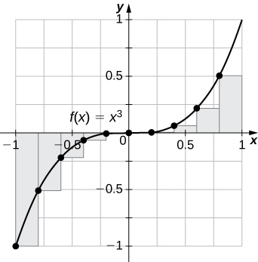

, . The left endpoint sum is an underestimate because the function is increasing. Similarly, a right endpoint approximation is an overestimate. The area lies between the left and right endpoint estimates.

33. **[T]** *L*100 and *R*100 for  on the interval 

Answer:

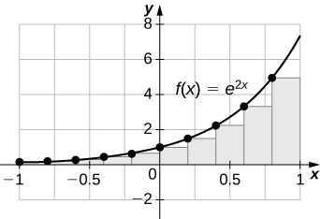

, . The plot shows that the left Riemann sum is an underestimate because the function is increasing. Ten rectangles are shown for visual clarity. This behavior persists for more rectangles.

35. Let  denote the total rainfall in Portland on the *j*th day of the year in 2009. Interpret .

Answer: The sum represents the cumulative rainfall in January 2009.

37. To help get in shape, Joe gets a new pair of running shoes. If Joe runs 1 mi each day in week 1 and adds  mi to his daily routine each week, what is the total mileage on Joe’s shoes after 25 weeks?

Answer: The total mileage is .

39. The following table gives the approximate increase in sea level in inches over 20 years starting in the given year. Estimate the net change in mean sea level from 1870 to 2010.

Approximate 20-Year Sea Level Increases, 1870–1990

|  |  |
| --- | --- |
| **Starting Year** | **20-Year Change** |
| 1870 | 0.3 |
| 1890 | 1.5 |
| 1910 | 0.2 |
| 1930 | 2.8 |
| 1950 | 0.7 |
| 1970 | 1.1 |
| 1990 | 1.5 |

Answer: Add the numbers to get 8.1-in. net increase.

41. The following table gives the percent growth of the U.S. population beginning in July of the year indicated. If the U.S. population was 281,421,906 in July 2000, estimate the U.S. population in July 2010.

Annual Percentage Growth of U.S. Population, 2000–2009

|  |  |
| --- | --- |
| **Year** | **% Change/Year** |
| 2000 | 1.12 |
| 2001 | 0.99 |
| 2002 | 0.93 |
| 2003 | 0.86 |
| 2004 | 0.93 |
| 2005 | 0.93 |
| 2006 | 0.97 |
| 2007 | 0.96 |
| 2008 | 0.95 |
| 2009 | 0.88 |

(*Hint:* To obtain the population in July 2001, multiply the population in July 2000 by 1.0112 to get 284,573,831.)

Answer: 309,389,957

**In the following exercises, estimate the areas under the curves by computing the left Riemann sums, *L*8.**

43.

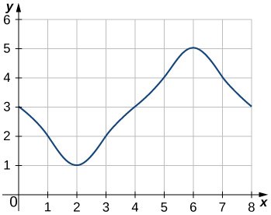

Answer: 

45.

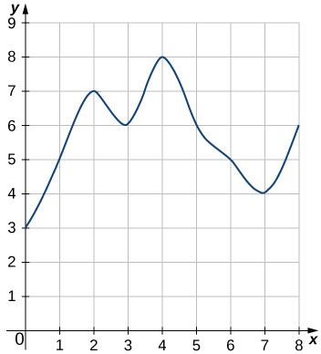

Answer: 

47. **[T]** Use a computer algebra system to compute the Riemann sum, *LN*, for  for  on .

Answer: , , 

**In the following exercises, use a calculator or a computer program to evaluate the endpoint sums *RN* and *LN* for . How do these estimates compare with the exact answers, which you can find via geometry?**

49. **[T]**  on the interval 

Answer: , , , , , and . By symmetry of the graph, the exact area is zero.

**In the following exercises, use a calculator or a computer program to evaluate the endpoint sums *RN* and *LN* for .**

51. **[T]**  on the interval , which has an exact area of 

Answer: , , , , , 

53. Explain why, if  and *f* is increasing on , that the left endpoint estimate is a lower bound for the area below the graph of *f* on .

Answer: If  is a subinterval of  under one of the left-endpoint sum rectangles, then the area of the rectangle contributing to the left-endpoint estimate is . But,  for , so the area under the graph of *f*  between *c* and *d* is  plus the area below the graph of *f* but above the horizontal line segment at height , which is positive. As this is true for each left-endpoint sum interval, it follows that the left Riemann sum is less than or equal to the area below the graph of *f* on .

55. Show that, in general, .

Answer:  and . The left sum has a term corresponding to  and the right sum has a term corresponding to . In , any term corresponding to  occurs once with a plus sign and once with a minus sign, so each such term cancels and one is left with .

57. For each of the three graphs:

1. Obtain a lower bound  for the area enclosed by the curve by adding the areas of the squares *enclosed completely* by the curve.
2. Obtain an upper bound  for the area by adding to  the areas  of the squares *enclosed partially* by the curve.

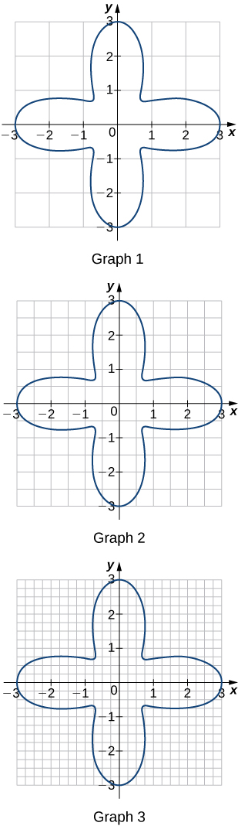

Answer: Graph 1: a. , ; b. . Graph 2: a. ; b. , . Graph 3: a. ; b. , .

59. A unit circle is made up of *n* wedges equivalent to the inner wedge in the figure. The base of the inner triangle is 1 unit and its height is . The base of the outer triangle is  and the height is . Use this information to argue that the area of a unit circle is equal to *π*.

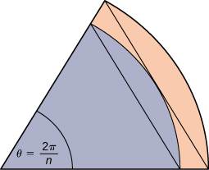

Answer: Let *A* be the area of the unit circle. The circle encloses *n* congruent triangles each of area , so . Similarly, the circle is contained inside *n* congruent triangles each of area , so . As , , so we conclude . Also, as , , so we also have . By the squeeze theorem for limits, we conclude that .

This file is copyright 2016, Rice University. All Rights Reserved.